TRAINING MANUAL

AAU e-Learning Guide manual
For Students

Prepared By: Learning Teaching Technologies Team
Prepared For: Addis Ababa University Students
Date: Feb, 2023

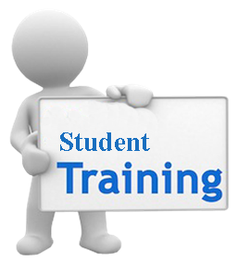

Learning management system (LMS)
A learning management system (LMS) is a software application or Web-based technology used to plan, implement, and assess a specific learning process. Typically, a learning management system provides an instructor with a way to create and deliver content, monitor student participation, and assess student performance. A learning management system may also provide students with the ability to use interactive features such as threaded discussions, video conferencing, and discussion forums.

Learning management systems

Moodle
Blackboard
E-Front
ATutor
WebCT
Etc…..

An easy way to communicate with students and staff where ever they are:
The news form automatically emails messages to all students and staff on the course. Forums can also be used to answer commonly asked questions – and prevent repeats, to provide a space for informal peer to peer student discussion or even online tutorials.

A quick way to share documents:
Moodle provides a place where you can easily create web pages with information about your course and provide links to word documents, slides, and other resources that your students will want to access.

Easy access to relevant and useful online resources:
The department and the university provide a wealth of materials and resources, but catering for so many different types of students it can be hard for learners to find those that are most relevant to them. You can use your Moodle to provide links directly to the resources that will be most useful for your students.

Online assignment handling:
When your students and tutors are not close to online assignment handling can save time and effort for everyone involved – whether it is just used for student submission with marking done on paper or the whole process is moved online saving time, postage and paper.

Moodle:- is a Learning Management System (LMS) that allows you to store your learning content and manage assessments online. Students can retrieve course content and upload assessments via Moodle. Moodle supports a range of different resource types that allow you to include almost any kind of digital content into your courses.
E-Learning material requirements
- Word files
- Presentations
- PDF files
- Video
- Web link
- Notices
- Assessments
- Animations
- Blog and discussion
- Chat
- Etc…..

Other advantages –

Save time and money – making resources available online can save time and money in photocopying
Control access to different areas – can make a space for dispersed tutors to communicate with each other as well as students. .
Use less paper – keep a central copy online so everyone can find the latest version of a course handbook etc. Provide handouts online and students only print out what they really need.
Designed to encourage collaborative learning – Moodle makes it easy to model the tutorial system online if you want to use it with globally distributed students.
Easy to experiment with new ideas and tools – a low risk way to incorporate new tools and ideas into your teaching.
Manage your materials – if all your course information is on Moodle this is easy access this year after year.

Other features and tools:

Course calendar – use this to flag important events to everyone on your course.
Profiles and contact information – help students and staff gets to know each other at the start of the course, also hold information about course team and students in one place.
Deliver content – post up slides etc
Video and audio – many academics find it easy to record lectures as podcasts or even arrange for videos of lectures or special events– posting these online and making it available to students is straight forward with Moodle
Group tools for students – there are many tools that students can use for collaboration with each other e.g. forums, wiki and chat

http://elearning.aau.edu.et
AAU eLearning site

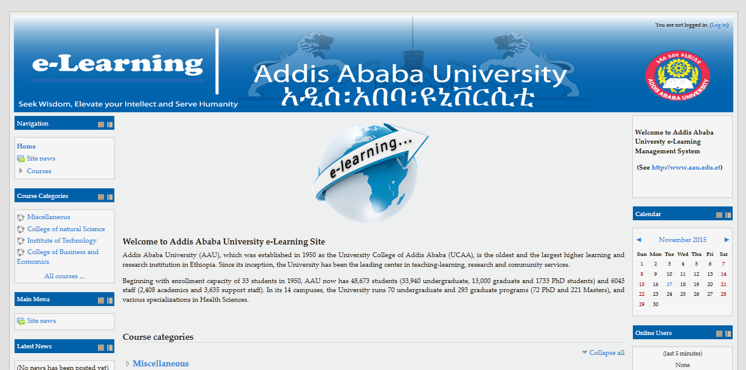

Login
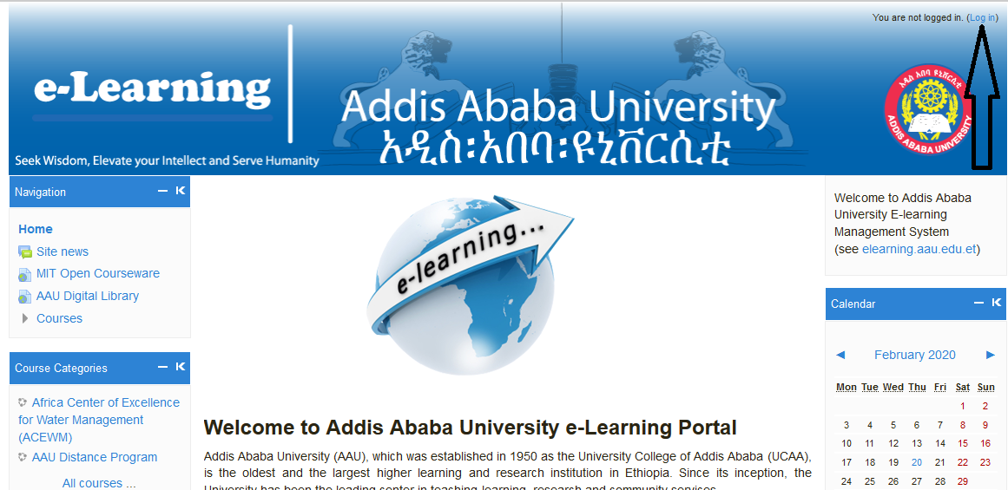

Log in to e-Learning Platform
Step1
- Click the log in on the right corner of the page (see the picture above)
Step2
- Enter your name and default password which get from your department on the username and password section then enter login. (see the picture below)

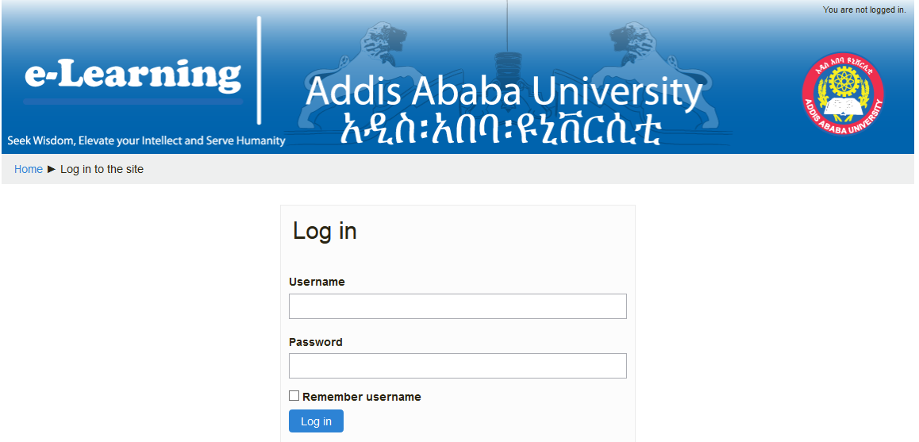
Step3
- The system will ask you to enter your unique personal new password, first enter your old password (get from your department) then your new password finally confirm your new password and enter save changes. ( see the picture below)
N.B The new password must have at least 8 characters, at least 1 digit(s), at least 1 lower case letter(s), at least 1 upper case letter(s), at least 1 non-alphanumeric character(s)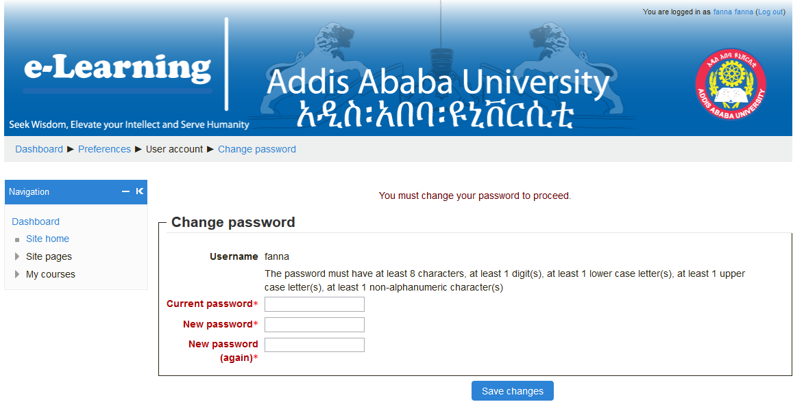
Step4
- The system confirms you that your old password changed to the new one, then click continue (see the picture below)
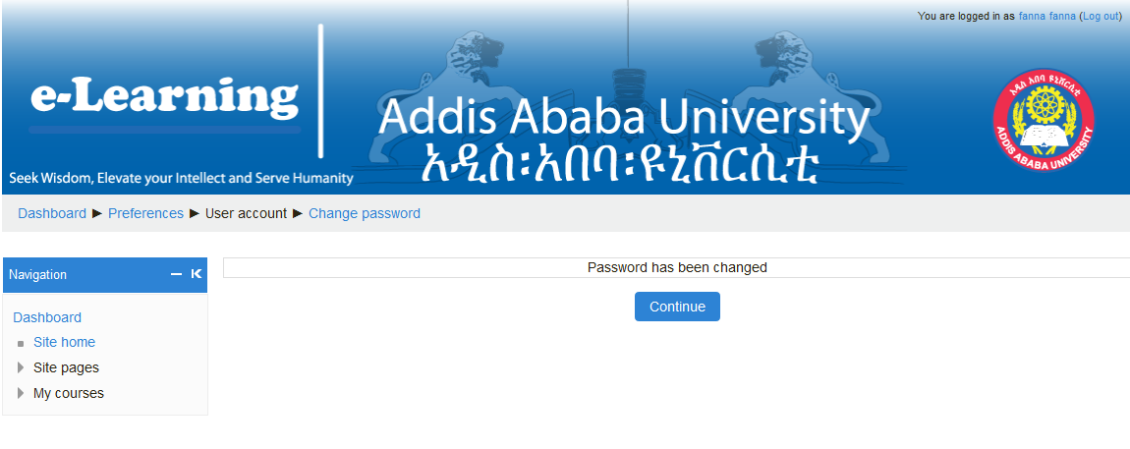
Step5
- Log out and login (at the right top corner) with the new password then the system leads you to your list of courses page.

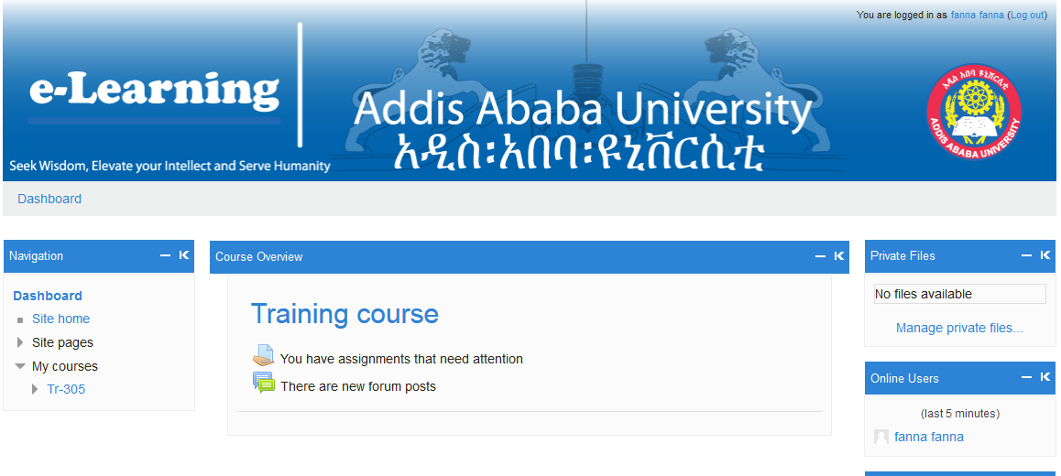

Step6
- Choose and participate to any of your courses ( download contents, see and submit Assignments, Chat, Quiz, Forum……)
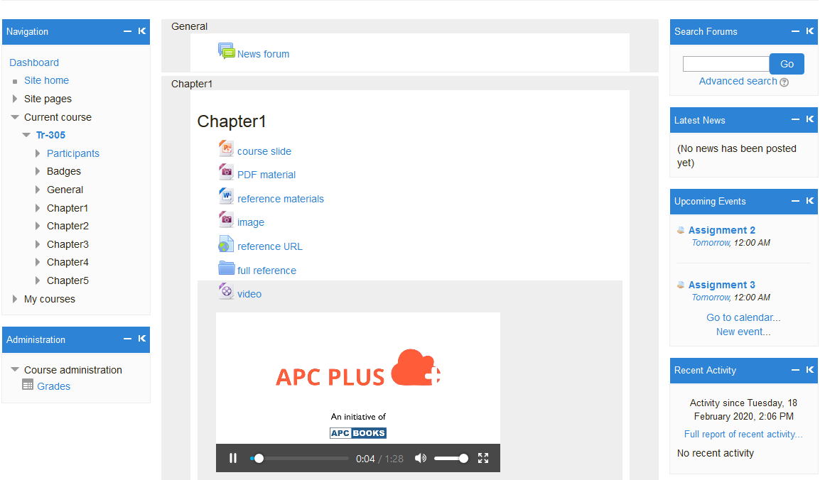
Step7
- Please secure your passwords and don’t forget to log out after you done.

