TRAINING MANUAL

AAU e-Learning Guide manual
For Teachers

Prepared By: Learning Teaching Technologies Team
Prepared For: Addis Ababa University Instructors
Date: Feb, 2023

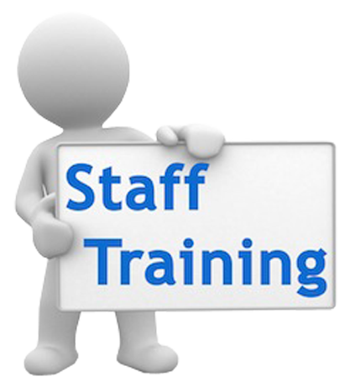

Learning management system (LMS)
A learning management system (LMS) is a software application or Web-based technology used to plan, implement, and assess a specific learning process. Typically, a learning management system provides an instructor with a way to create and deliver content, monitor student participation, and assess student performance. A learning management system may also provide students with the ability to use interactive features such as threaded discussions, video conferencing, and discussion forums.

Learning management systems

Moodle
Blackboard
E-Front
ATutor
WebCT
Etc…..

An easy way to communicate with students and staff where ever they are:
The news form automatically emails messages to all students and staff on the course. Forums can also be used to answer commonly asked questions – and prevent repeats, to provide a space for informal peer to peer student discussion or even online tutorials.

A quick way to share documents:
Moodle provides a place where you can easily create web pages with information about your course and provide links to word documents, slides, and other resources that your students will want to access.

Easy access to relevant and useful online resources:
The department and the university provide a wealth of materials and resources, but catering for so many different types of students it can be hard for learners to find those that are most relevant to them. You can use your Moodle to provide links directly to the resources that will be most useful for your students.

Online assignment handling:
When your students and tutors are not close to online assignment handling can save time and effort for everyone involved – whether it is just used for student submission with marking done on paper or the whole process is moved online saving time, postage and paper.

Moodle:- is a Learning Management System (LMS) that allows you to store your learning content and manage assessments online. Students can retrieve course content and upload assessments via Moodle. Moodle supports a range of different resource types that allow you to include almost any kind of digital content into your courses.
E-Learning material requirements
- Word files
- Presentations
- PDF files
- Video
- Web link
- Notices
- Assessments
- Animations
- Blog and discussion
- Chat
- Etc…..

Other advantages –

Save time and money – making resources available online can save time and money in photocopying
Control access to different areas – can make a space for dispersed tutors to communicate with each other as well as students. .
Use less paper – keep a central copy online so everyone can find the latest version of a course handbook etc. Provide handouts online and students only print out what they really need.
Designed to encourage collaborative learning – Moodle makes it easy to model the tutorial system online if you want to use it with globally distributed students.
Easy to experiment with new ideas and tools – a low risk way to incorporate new tools and ideas into your teaching.
Manage your materials – if all your course information is on Moodle this is easy access this year after year.

Other features and tools:

Course calendar – use this to flag important events to everyone on your course.
Profiles and contact information – help students and staff gets to know each other at the start of the course, also hold information about course team and students in one place.
Deliver content – post up slides etc
Video and audio – many academics find it easy to record lectures as podcasts or even arrange for videos of lectures or special events– posting these online and making it available to students is straight forward with Moodle
Group tools for students – there are many tools that students can use for collaboration with each other e.g. forums, wiki and chat

http://elearning.aau.edu.et
AAU eLearning site

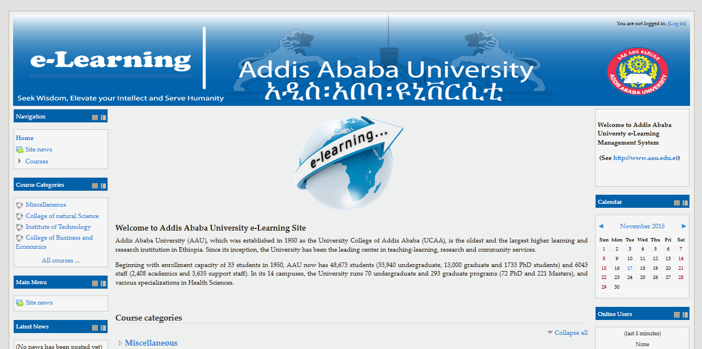

Roles
e-Learning portal roles facilitate controlling what a user can and cannot do within e-Learning and within Moodle courses. e-Learning administrators have the ability edit the permissions and capabilities of roles and create new roles. Student and teacher are the most commonly used roles.
- Guest role – Guests have minimal privileges. They can view course activities but cannot enter text anywhere. As with all other roles, Guests are required to log in to portal before they access a course.
- Student role – Students generally have fewer privileges than teachers within a course. They can submit assignments for grading, make posts to forums, and generally participate in a course. Students cannot edit any of the course settings and cannot use portal Quick mail feature to send mail to an entire class. Students see their own grades only.
- Non-editing teacher role – This role cannot add activities or resources, but can view and edit grades.
- Teacher role – Teachers can do anything within a course, including changing the activities and grading students.
- Authenticated user role - By default, authenticated users have permission to edit their own profile, send messages, blog and do other things outside of courses.
- Course creator role – This role can create a course, assign Teachers, plus have all the privileges of a Teacher.
- Administrator role – Administrators can do almost anything and go anywhere. It is recommended that there are one or two people with the administrator role.

LOGIN
You must be logged in in order to edit a course and use most of the features described below.
Basics
The course settings page offers the teacher many controls. These include who can come into the course, how the course is laid out and other potential functions.
Most course homepage formats are broken into course sections. Resources and activities are added to each section.
Editing course section
To add or alter activities or resources a teacher must use the "Turn editing on" button on the course homepage. The same button will also turn editing off. Similarly, the "switch role to” button allows the teacher to see the course page as a student, guest and non-editing teacher would see it.
To add items to a section, you will use the pull down boxes for activities and resources.

Add or remove topic/week sections in e-Learning course
Topic sections are the large content zones on the main page of each eLearning course. You can accommodate the amount of content in your course by reducing or increasing the number of the sections that are shown (5 by default).
- In the 'Settings' block, choose Edit settings under Course administration.
- In the General settings area, scroll down until about the middle of the box. Once there, use the Number of weeks/topics dropdown to select how many sections or weeks there will be in the course.
- When finished, click the Save changes button at the bottom of the page.

Changing topic titles

1. Click Turn editing on in the top right of your course page.
2. Go to the topic area that you want change and click the cog icon.
3. In the Summary page uncheck the ‘Use default section name’ box.
4. In Section name enter the name of your topic
5. In Summary you can also enter a short summary of what this topic area contains (this is optional).
6. Click Save changes at the bottom of the page.

Resources

e-Learning portal supports a range of different resource types that allow you to include almost any kind of digital content into your courses. These can be added by using the add a resource dropdown box when editing is turned on.
- Book
- File
- Folder
- Page
- Url
- Etc..
Adding resource
1: Select the Course you want to upload to
2: Turn Editing On

Add a resource

You will now see the layout has changed. Here you can edit individual sections- called "topics". To edit the name of a Topic, press the Gear Cog Icon under the topic's name. In the Topic's box that you want to upload a document, link, or assignment to, press Add an activity or resource.

Select the type of resource

The box will pop up, where if you scroll down on the left side will bring you to the resources menu. Select the type of resource and press add.

Add details about the file and finish

At this step, you can name the file, add a description to that file and lastly, upload it. After you can either Save or return to course or Save and display, which would allow you to see the file as you've uploaded it.
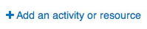

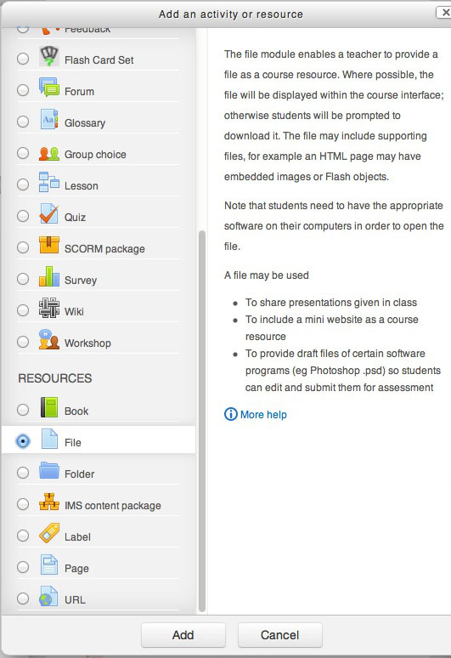

Activity

There are a number of robust interactive learning activity modules that you may add to your course with the "Add an activity" drop down menu.
- Assignment
- Forum
- Quiz
- Glossary
- Wiki
- Etc..
Adding activities
Adding activities works much the same way as adding resources.
1. Once editing is turned on, choose Add an Activity or Resource.
2. Choose the type of activity you would like to add to your course, such as an Assignment.

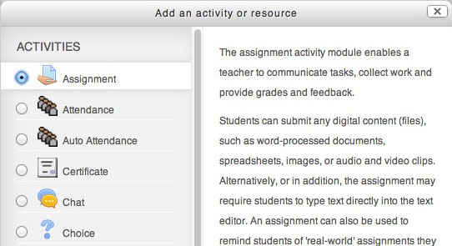

Blocks
Course administration block
A teacher with editing rights will also have a course administration block. This is an important tool for a teacher. It has sub menus for course: backup, restore, Assign roles, grades, activity logs/reports, Files and the useful Course settings.

Enrolling student
- Go to Administration > Course administration > Users > Enrolled users
- Click the 'Enroll users' button at the top right or bottom left of the page
- Use the 'Assign roles' dropdown if you wish to change the role
- Select enrolment options as appropriate
- Browse cohort (site-wide groups) and Browse users or search for the user. (Note that when searching for users, exact matches are listed first.)
- Click the Enroll button opposite the user. The user will indent in the list and the enroll button will disappear, indicating that the user is enrolled.
- When you have finished, click the 'Finish enrolling users' button (or simply close the enroll users box)

